Simulation of Resistor-Inductor and Resistor-Capacitor Circuits

Nathan Gillispie

Lab Partner: Luke Alford

Date of experiment: October 27

# Abstract

An RC circuit was built and the voltage across the capacitor was measured. An RC circuit with the same values of capacitance and resistance was numerically simulated from differential equations derived from Kirchhoff’s laws. First the time constant was estimated as ln(2)V0, from the graph, then from the decay of the exponential fit, then from the simulation: the measured results were 3.55ms, 3.546±0.007ms and 3.3ms respectively. Discrepancies are likely due to the tolerances of the resistor and capacitor which may not be exactly the resistance and capacitance stated.

# Introduction

Inductor-resistor (RL) and resistor-capacitor (RC) components in series are abundant in modern circuitry. It is important to understand the nature of these circuits for that reason.

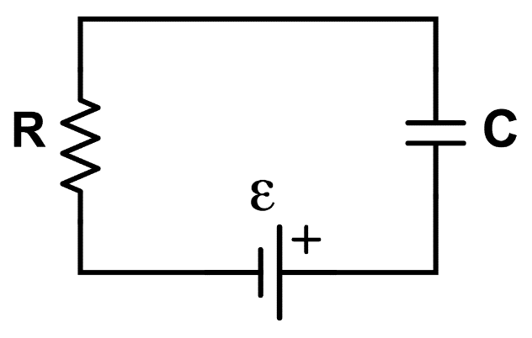

**Figure 1:** Connection diagram of a standard RC circuit.

In RC circuits we find that the voltage across the capacitor “lags behind” the supplied EMF. In IR circuits find that the voltage across the resistor follows a similar pattern. If we supply the emf as a step function, we can fit the supplied voltage to an exponential function and find the time constant k, which usually follows one of these two equations

$$V\left(t\right)=V_{0}e^{-kt}$$

$$V\left(t\right)=V_{0}{(1-e}^{-kt})$$

Where V(t) is the voltage across a capacitor or inductor after a drop in emf at t=0 with initial voltage V0. Because of this decay, we can mathematically model each voltage as a function of the input emf. By using differential equations, we can describe the behavior of these circuits. In RC circuits the equation is as follows:

$$dQ=\frac{Vs-\frac{q}{C}}{R}dt$$

Where dQ is change in charge across the capacitor, Vs is the voltage source, q is the existing charge, C is the capacitance, R is the resistance and dt is the timestep. For an RL circuit the equation is

$$di=\frac{Vs-i*R}{L}dt$$

For di as the change in current, i as existing current, R as resistance, L as inductance and dt as timestep. We can then use computers to simulate the results of the experiment by numerically solving the differential equations.

# Method

A 100 μF capacitor and 33Ω resistor were connected in series to a square wave generator. An oscilloscope was connected across the capacitor to measure the voltage. The data was saved to physics data assistant and exponential fits were generated for each circuit only for the data between a half cycle of the generator. The decay constants were noted. The same process was repeated for a 33Ω resistor and 0.0083H inductor. Using the differential equations outlined above, the circuits were simulated in vPython and the time constant results are compared to the results from the original data.

# Results and Data

The time constants calculated for the RC circuits first came from the first equation when k is set to one. In other words, the time at which the voltage is the initial voltage (4V) multiplied by e-1 = 0.368. This method is done mostly graphically so no uncertainty is determined.

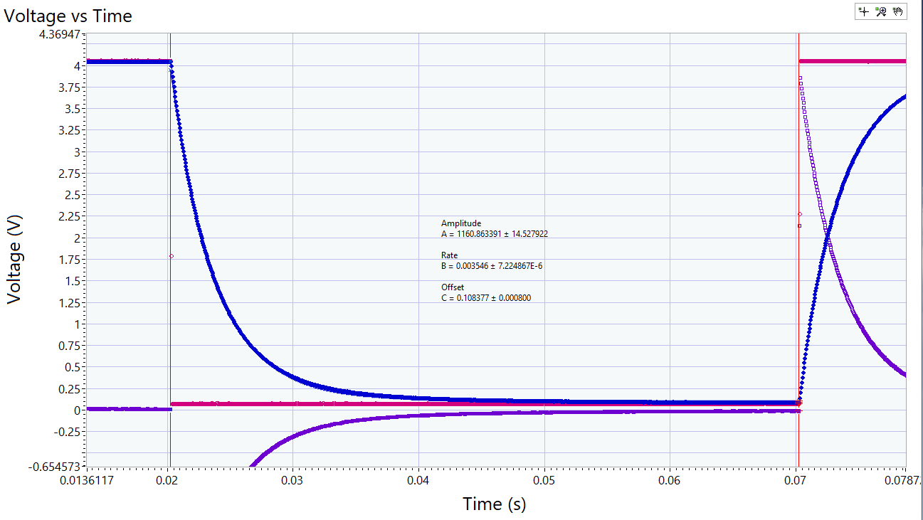

**Figure 1:** Voltage over time plot with exponential fit.

The second way is the rate B from the exponential fit of the measured data. This method was used for all trials including the voltage over time for inductors.

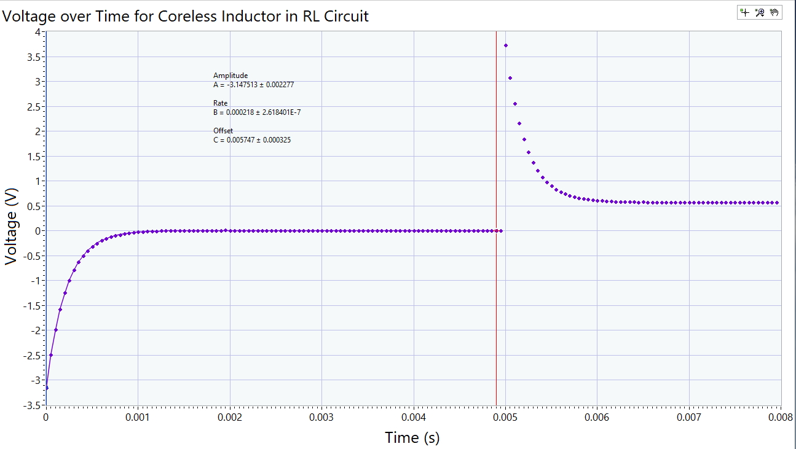

**Figure 2:** Voltage over time plot with exponential fit.

The simulation gave strikingly similar results. The exact frequency of the wave generator was not originally determined but all the really is derived from the simulation is the rate constant which is only dependent on the resistance and capacitance, not input voltage.

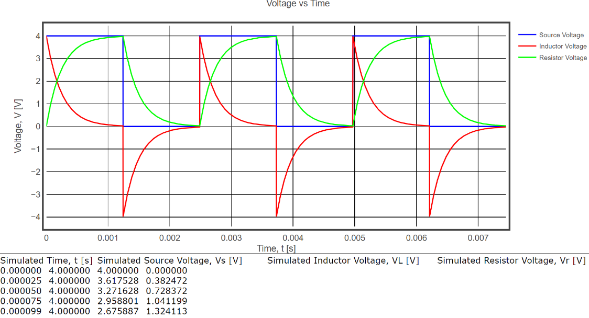

**Figure 3:** Simulated voltage over time plot with exponential fit for the IR circuit.

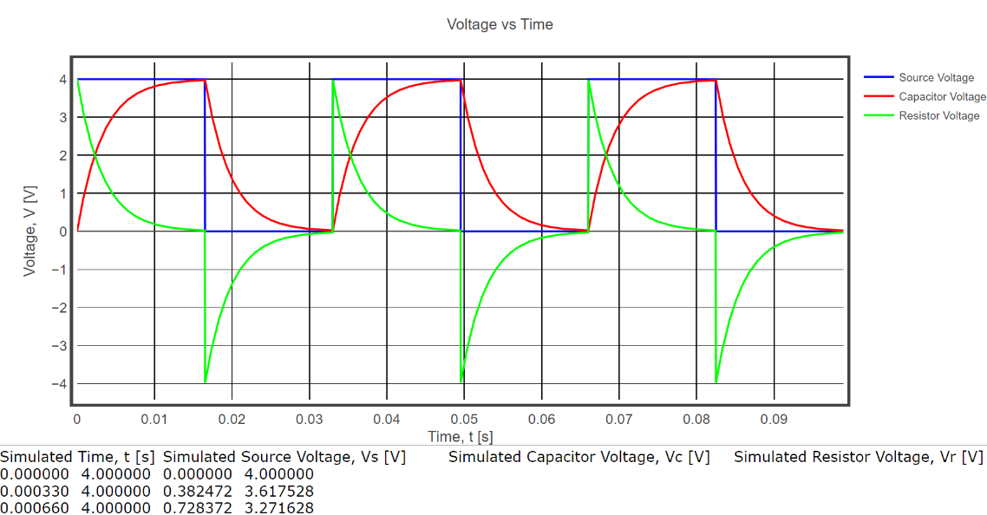

**Figure 4:** Simulated voltage over time plot with exponential fit for the RC circuit.

The determined rate constant for the simulation is 3.3ms, which is not within the two standard error criterion for the measured RC circuit value. However, we must take into account the tolerances of the individual components. Although the tolerances of the resistor and capacitor were never recorded, it is safe to assume they have both 5% tolerance meaning the summed tolerance is 10%, worst case scenario. Since the behavior between these two components is nonlinear we cannot necessarily imply that the tolerance of the time constant is 10%. Either way, this means the uncertainty of this measurement is about 0.3ms. Now we note that the measured values are both within two standard errors of one another.

# Conclusion

The measuring of time constants of RC and RL circuits were done in a variety of ways. Since the values only depend on the resistance and capacitance, or resistance and inductance, the written values for each component can be used for simulating the time constants. The time constants measured from the exponential fit and from the simulation of the RC circuit are measured as 3.546±0.007ms and 3.3±.3ms. Since both agree within two standard error, we can conclude our assumptions about the tolerances of the individual components are not disproven and that the differential equations describing the change of voltage is likewise not disproven.